module 3
Question 1
Identify all duplicate cases using prof. Using all observations, find the average and standard deviation for age. Repeat the analysis by first filtering the data set to include one observation for each instructor with a total number of observations restricted to 94.
Frequencies

Statistics
Indicator of each last matching case as Primary
N | Valid | 463
 | Missing | 0

Indicator of each last matching case as Primary
 |  | Frequency | Percent | Valid Percent | Cumulative Percent
Valid | Duplicate Case | 369 | 79.7 | 79.7 | 79.7
 | Primary Case | 94 | 20.3 | 20.3 | 100.0
 | Total | 463 | 100.0 | 100.0

Descriptives

Descriptive Statistics
 | N | Mean | Std. Deviation
age | 463 | 48.37 | 9.803
Valid N (listwise) | 463

Descriptive Statistics
 | N | Mean | Std. Deviation
age | 94 | 47.55 | 10.257
Valid N (listwise) | 94

Question 2
Using a bar chart, demonstrate if instructors teaching lower division courses receive higher average teaching evaluations.

Question 3
Using gender differentiated scatter plots, plot the relationship between age and eval.
GGraph

Question 4
Differentiated by credits, create a box plot for beauty.

GGraph

Question 5
Using OLAP cubes reproduce the following table.
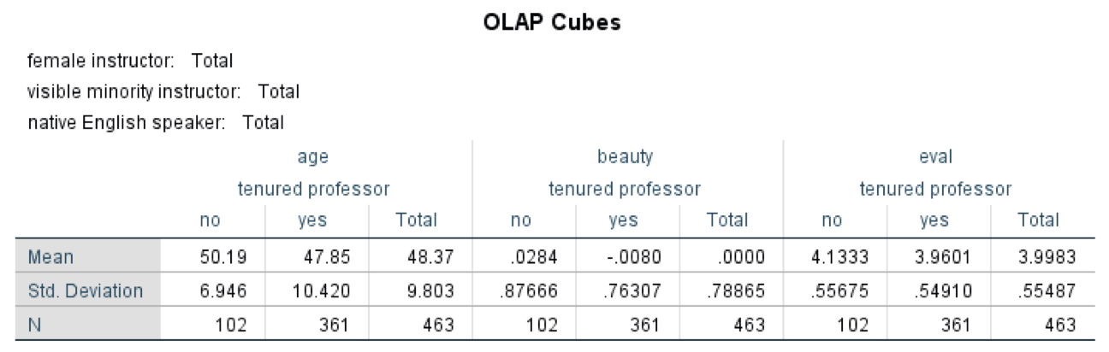

OLAP Cubes

Case Processing Summary
 | Cases
 | Included |  | Excluded |  | Total
 | N | Percent | N | Percent | N | Percent
age * tenure | 463 | 100.0% | 0 | 0.0% | 463 | 100.0%
beauty * tenure | 463 | 100.0% | 0 | 0.0% | 463 | 100.0%
eval * tenure | 463 | 100.0% | 0 | 0.0% | 463 | 100.0%

OLAP Cubes
tenure: Total
 | N | Mean | Std. Deviation
age | 463 | 48.37 | 9.803
beauty | 463 | .0000 | .78865
eval | 463 | 3.9983 | .55487
Question 6
Is there a systematic relationship between gender and division? Produce a cross tabulation between the two with percentages to answer this question.
Crosstabs

Case Processing Summary
 | Cases
 | Valid |  | Missing |  | Total
 | N | Percent | N | Percent | N | Percent
gender * division | 463 | 100.0% | 0 | 0.0% | 463 | 100.0%

gender * division Crosstabulation
 |  |  | division |  | Total
 |  |  | lower | upper
gender | female | Count | 60 | 135 | 195
 |  | % within gender | 30.8% | 69.2% | 100.0%
 |  | % within division | 38.2% | 44.1% | 42.1%
 |  | % of Total | 13.0% | 29.2% | 42.1%
 | male | Count | 97 | 171 | 268
 |  | % within gender | 36.2% | 63.8% | 100.0%
 |  | % within division | 61.8% | 55.9% | 57.9%
 |  | % of Total | 21.0% | 36.9% | 57.9%
Total |  | Count | 157 | 306 | 463
 |  | % within gender | 33.9% | 66.1% | 100.0%
 |  | % within division | 100.0% | 100.0% | 100.0%
 |  | % of Total | 33.9% | 66.1% | 100.0%

Chi-Square Tests
 | Value | df | Asymptotic Significance (2-sided) | Exact Sig. (2-sided) | Exact Sig. (1-sided)
Pearson Chi-Square | 1.482ª | 1 | .223
Continuity Correction^{b} | 1.250 | 1 | .264
Likelihood Ratio | 1.490 | 1 | .222
Fisher's Exact Test |  |  |  | .234 | .132
N of Valid Cases | 463
a. 0 cells (0.0%) have expected count less than 5. The minimum expected count is 66.12.
b. Computed only for a 2x2 table
Question 7
Are beauty and age correlated? Using Pearson Correlation to answer this question.
Correlations

Correlations
 |  | beauty | age
beauty | Pearson Correlation | 1 | -.298**
 | Sig. (2-tailed) |  | <.001
 | N | 463 | 463
age | Pearson Correlation | -.298** | 1
 | Sig. (2-tailed) | <.001
 | N | 463 | 463
**. Correlation is significant at the 0.01 level (2-tailed).

